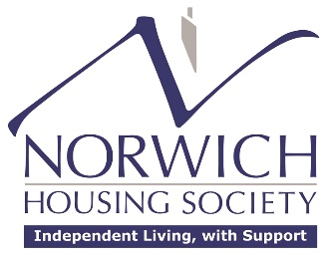

BOARD MEMBER – VACANCY

Norwich Housing Society Ltd has been providing homes for older people with support in Norwich since 1934. The Society is a registered charity governed by a Board of enthusiastic people from various professional backgrounds. We are looking to appoint additional Board Members who would like to make a difference to social housing for older people in Norwich. We seek to sustain a well-rounded Board with diverse perspectives and experience, however, we are particularly interested in people with Finance, Housing Management and Property Maintenance backgrounds to join and influence the dedicated work of the Society.

The work, whilst not remunerated, is incredibly rewarding. The commitment is currently the equivalent of 8 to 10 days per year. Please contact the office 01603 625078 or email:
info@norwichhousingsociety.co.uk for further information.

